Drowsiness Detector

Objective:

The objective of the project was to detect drowsiness from a normal picture of a person irrespective of what lies in his/her background. A drowsiness detector such as this could be used in the automobile industry where ‘Drowsy driving’ accounts for about 100,000 crashes annually on the roadway, 71,000 injuries and 1,550 fatalities each year. **(**[AAA Foundation](https://aaafoundation.org/prevalence-drowsy-driving-crashes-estimates-large-scale-naturalistic-driving-study/)**)**

Methodology:

Code was written in jupyter lab and was run using the python kernel.  
Used pytorch version 1.8.1 for python using pip and CUDA 11.1 on windows.  
Imported dependencies such as matplotlib and OpenCv into the jupyter notebook.  
Tested the ultralytics yolov5s algorithm (<https://github.com/ultralytics/yolov5>) in object detection by using random images from the net. Object detection was successful. Main reference: <https://www.youtube.com/watch?v=tFNJGim3FXw>

Trained custom models by using images and labels of custom datasets:

Dataset 1 contained 20 awake and 20 drowsy images of myself. The images were labelled using LabelImg (<https://github.com/tzutalin/labelImg>).   
The result using this dataset turned out to detect only my face properly but found it difficult to detect when it saw different faces.  
Using dataset 1, exps 1-15 were conducted with different settings. Only exp 8 and 15 yielded predicted results. Other exps faced various errors/interruptions some of which are described in the ‘points learned’ section.

Dataset 2 contained 100 random images of eyes only. The objective was to focus on the eyes instead of the entire face. <https://www.kaggle.com/datasets/muhammadhananasghar/oace-open-and-close-eyes-dataset>  
Dataset 2 was used to focus only on the eyes but turned out not detecting anything. When only the eyes were in the frame, the model could detect drowsiness. However, the objective of the project was not to predict drowsiness with only eyes.

Dataset 3 contained a total of 313 images of awake, low vigilant, and drowsy faces.  
<https://www.kaggle.com/datasets/mak1999/yolov5-drowsy>. Executed experiments 18 to 32 with different values for image size, epochs, and batch sizes. Many of those experiments caused various errors and ‘CUDA out of memory’ was the main error (refer ‘points learned’ section below).

experiment 27 summary:  
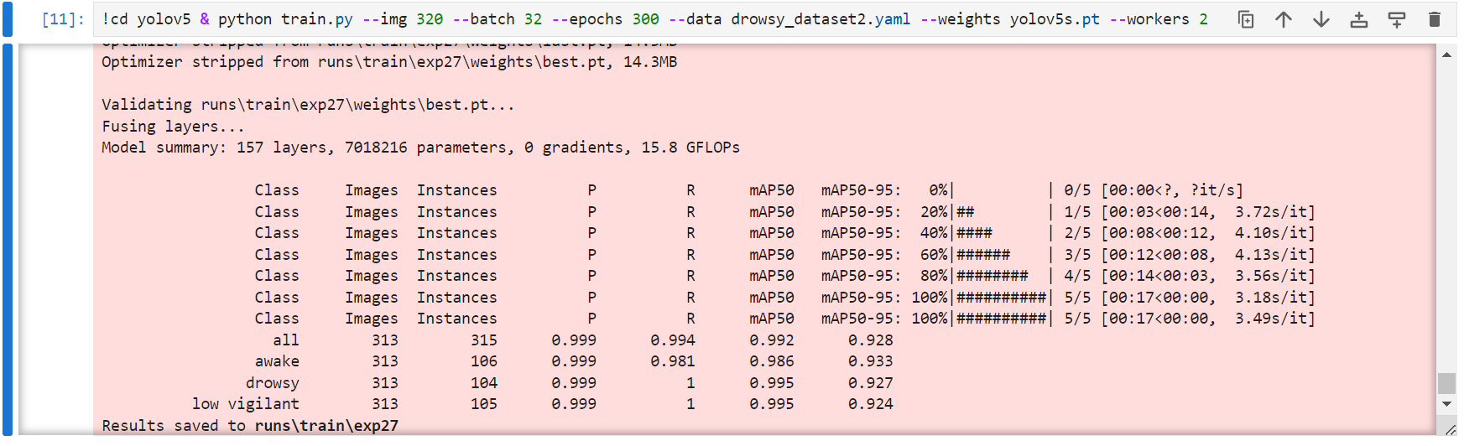  
Outcome: model trained on prelabeled dataset 3(from kaggle) was unable to correctly predict between awake, low vigilant and drowsy.

Since the outcomes of the prelabeled dataset found on Kaggle did not yield proper results, I relabeled those 313 images by focusing the labels only on the eyes.

After dataset 3 was relabeled by prioritizing only on the eyes, exp 32 was conducted.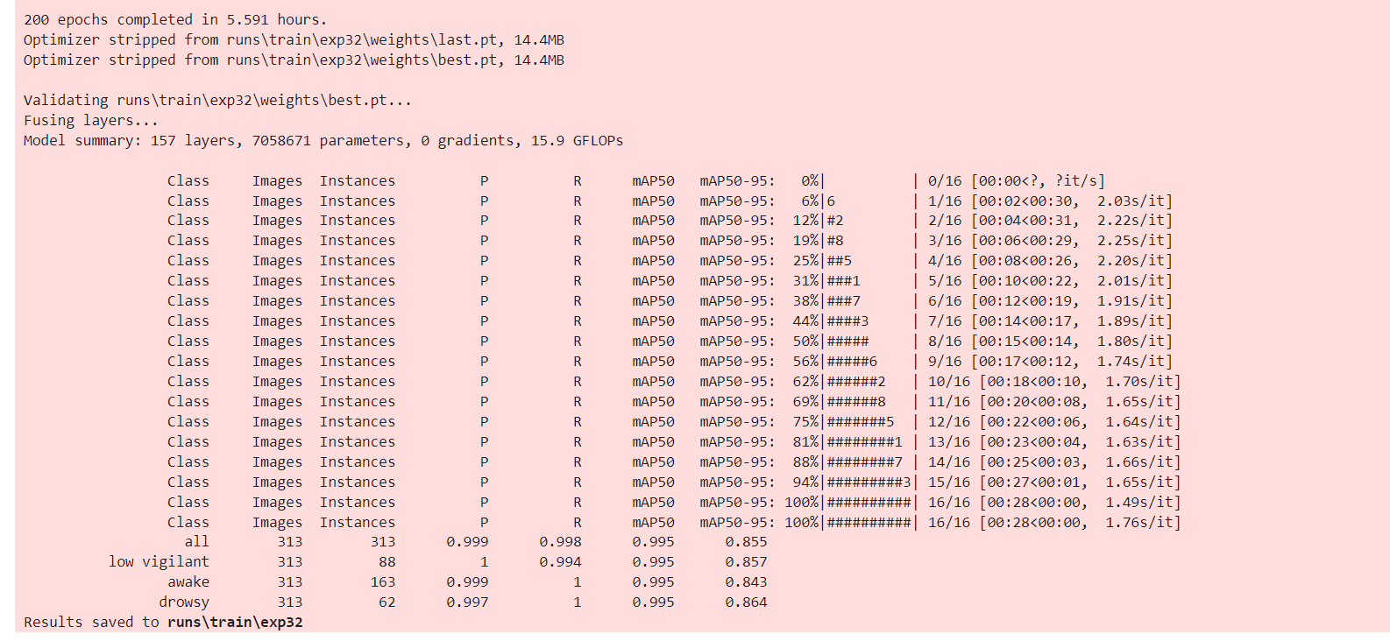  
Model of exp 32 that was trained on the relabeled dataset 3 yielded satisfactory results. It was able to properly detect awake and drowsy states. Since the number of images in the low vigilant state were less compared to that of awake, the model is still ambiguous when it tries to detect the low vigilant state. The below images are from testing Model 32.

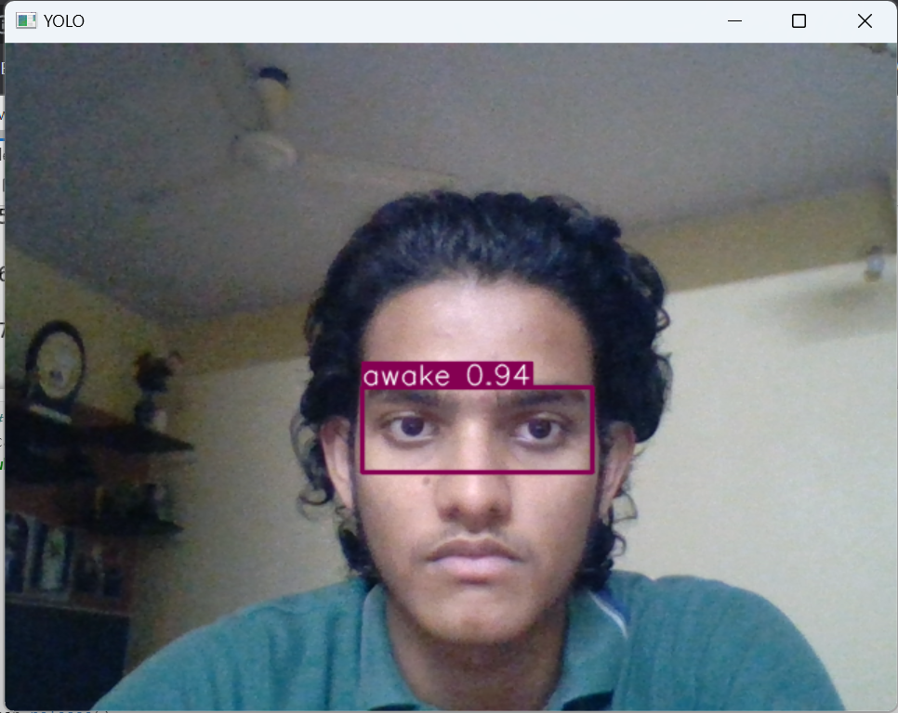

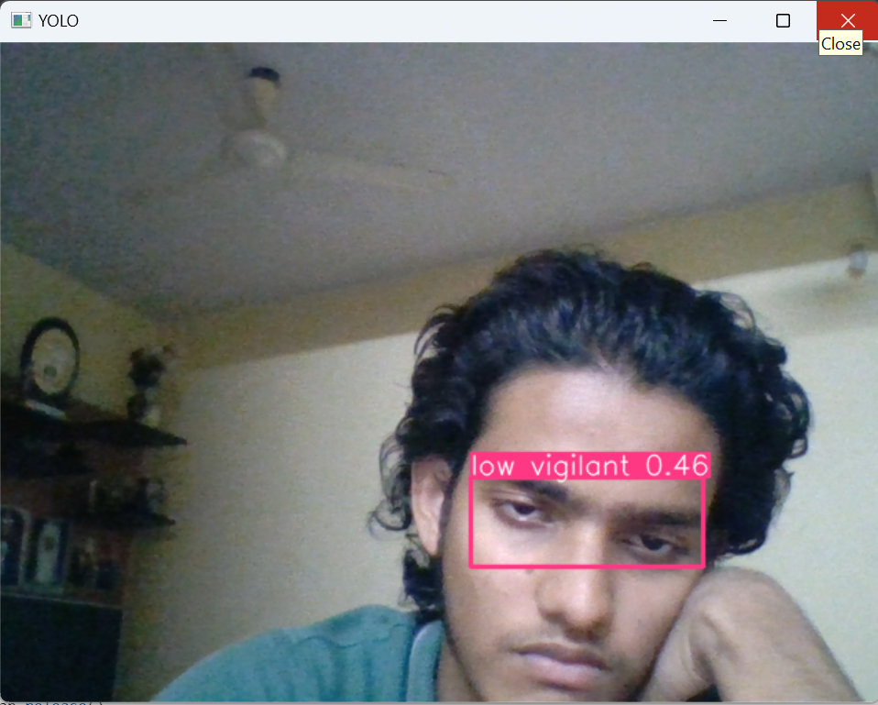

As you can see, there is only a fine line between the drowsy and low vigilant states. One can assume that the low-vigilant and drowsy states are almost the same.

I am trying to upload this model to raspberry pi and use a real life scenario of detecting drowsiness in different lighting conditions.

Points learned from experiments throughout the project:

Dataset must contain images of different faces  
Dataset must contain images taken from different distances from the camera.  
Dataset must contain images in different lighting  
Dataset must contain images of different quality.  
Labels must be properly assigned.  
Hardware limitations abruptly stopped experiments. Restarting the computer helped in creating free RAM space sometimes.  
Electricity cuts in India resulted to a disconnected kernel in jupyter lab which also led to incompleted experiments.

The models of each successfully completed experiment can precisely distinguish between drowsy and awake when a picture from the respective dataset, that was used to train the model, was used to test it also.   
The problem arises when a completely new picture is used to test it. The model cannot predict with certainty whether the person is awake or drowsy. This problem may be due to the fact the dataset might be too small for the model to train on.

“CUDA out of memory error” unresolved for img size of 480 and 640.   
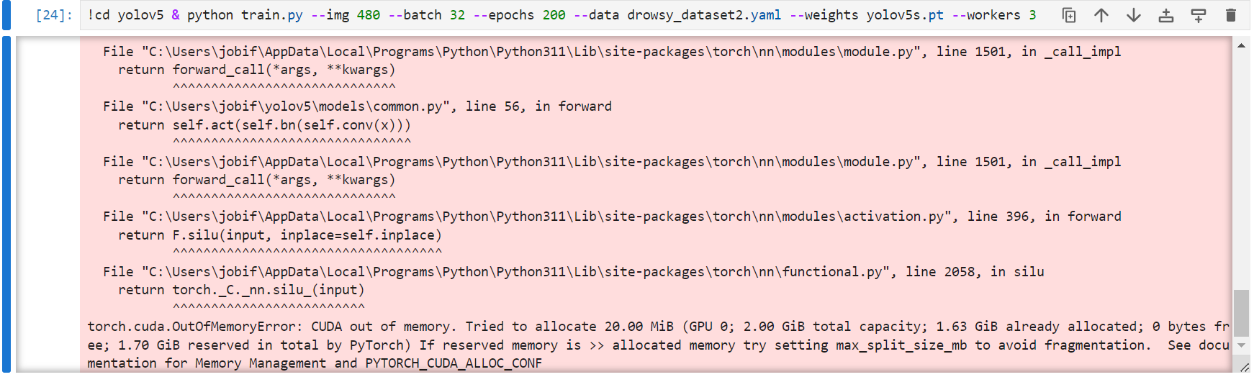  
It works for img size of 320 with high batch size and epochs. Img size of 480 works with only batch size of 10. Anything higher causes the “CUDA out of memory error”. This occurs probably due to the limit in hardware properties such as RAM, VRAM and GPU of my laptop.